# 2.1 Introduction to analysis

Analysis is one of the most important phase of SDLC to build a project. It is a part of project where we have to identify what is the project strategy? And the direction of a project. Analysis is a description of all aspects of the current system and also existing problems. Analysis structured all the requirements of information system.

The following are the activities which are involved in analysis:

1. Firstly, we have to identify what is the need of project?
2. We have to evaluate a system for feasibility.
3. Economic and technical analysis should be performed.
4. We have to establish a schedule.
5. System definition should be created.

Analysis is performed for making a decision and also for problem solving. If we did analysis, we can achieve goals and objectives for a project. Analysis will identify the problems why things have not worked. It will be focused on solution rather than seeking blame. Analysis is also done to improve your work. For change, analysis share understanding and ownership of decisions.

**PEST ANALYSIS:** It is a simple and widely used tool helps to analyze the political, economic, sociological and technological issues. It also assessed the effects of legal and environmental issues in an organization. Knowledge of management, marketing and organization growth and decline is also can be understand by PEST.

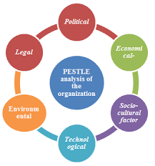

Figure : Pest analysis

**Political:** political influence on an organization such as environmental and legal issues can be assessed by using political factor. In my project, environment mayn’t be suitable to complete a project.

**Economic**: local, national global influence like recession, economy situation and trends can be assessed by using economic factors. There are lots of economic factors that occurs during my project. Trends will be changes and maybe my project will not be fruitful according to the trends.

**Sociological:** It assess ways in which a society can influence on an organization such as lifestyle, advertising and publicity etc. In a project, there should be so much advertisement and publicity. By doing this, my project will be known.

**Technological:** Impact of new technology on an organization such as rapid development, non-compatibility can be accessed by using this factor. My project will be affect by this factors because technology has been developing rapid day by day.

Example of pest:

* For developing a competitive strategy.

**CATWOE ANALYSIS:** It is a part of soft system methodology used to identify what the project is trying to achieve. It helps to categories all the people, processes and external factors in the information system that is being analyses (Business Change Academy, 2017). CATWOE stands for:

**C**= customers/clients  **W**= world view

**A**= actors/agents  **O**= owners

**T**= Transformations **E**= environment

**Customer:** Customers or clients are stakeholder for whom the system exists. In this step, system gets benefits by changing process. This is the first step that identify a customer and understanding how the system affects them. In my project, customer is patients. They can login to see the detailed information about clinic.

**Actors:** actors or agents are directly involved with the system. For implementation of changes in the system, these people are involved. Actors means admin, receptionist and dentist in my project. Their role is according to the organization.

**Transformations:** This step is called changes step where the process bring about. It describes what processes will be affected by development of the system. There are lots of transformation in my project such as: patients can book appointment for checkup. In past years, there is no any functions like this. So, by this transformation time will be save.

**World View:** worldview identify how the development of system influences all around the organization. It also explain the transformation of system. By staying every corner of world, people can research about this clinic and get to know many information through internet.

**Owners:** owners are the decision maker who have authority to make the changes decide how to run a project in a future. Owners will be only one in my project i.e. admin. Admin can update and handles any kinds of information of clinic.

**Environment**: environment is one of the most important phase. We have to know the social, economic issues for developing a project. We have to investigate what will be affect for a project. Examples are: regulations, financial constraints etc. There should be good environment to do any work. If my clinic project environment is good, many patients will came to checkup.

# 2.2 Feasibility Study

Feasibility study is an analysis which is used to measure the ability for completing a project successfully by including all necessary factors. It aims is to know all the strength, weaknesses, opportunities and threats that are present in a project. A well-designed feasibility study describe the details of operation, management and policies of a project. The main objectives of feasibility study is to understand all the concepts, plan and aspects of a project and should be alert of potential problems that could occur while implementing the project.

Feasibility study is divided into four parts:

1. **Economic feasibility**: It concludes that skillful software can generated financial gains of an organization. It focus on issues like cost of hardware, software and training.
2. **Technical feasibility:** Recent resources like (hardware, software) and technology are assessed by this feasibility to accomplish user requirement within allocated time and budget. There should be update and upgrade of resources and technology. In this feasibility, relevant technology is performed which are established and stable.
3. **Schedule feasibility:** This means that the project have to be completed within scheduled time limits. To control the schedule feasibility, project have to complete on time and there will not be a loss of utility. GANTT CHART is an example of schedule feasibility.
4. **Operational feasibility:** This feasibility is highly dependent on human resources. To solve the business problems and user requirements it assessed software performance step by step. In this feasibility, tasks like suggested solution by the software development team acceptable is determined.
5. **Legal feasibility:** This feasibility concludes that every proposed system should be comply with legal environment.

# 2.3 Requirement analysis

Requirement analysis is one of the most important phase of SDLC which determines user expectation for a new or modified product. Firstly, we have to identify what the user want or expectations from a project. Then a system is made according to user requirements.

Requirement analysis includes:

1. **Focus groups:** Here, question can be used to gather data from several sources at one time.
2. **Observation:** It is a direct method of collecting information. Problems can be easily identify. There is an involvement of users.
3. **Documentation:** It is a good source of development and can clarify the understanding.

# Functional

Functional requirements relates to the technical and behavioral functionality of a system. It identify what system should be during a project.

* The following points are the functional requirements.

|  |  |
| --- | --- |
| **Functional ID** | **Title** |
| F1 | Register |
| F2 | Login |
| F3 | Help |
| F4 | Contact Us |
| F5 | Update patient profile |
| F6 | Book Appointment |
| F7 | Blog |
| F8 | Delete Blog |
| F9 | Add Patients |
| F10 | Update Patient |
| F11 | Delete Patient |
| F12 | Add Doctor |
| F13 | Update Doctor |
| F14 | Delete Doctor |
| F15 | Add Category |
| F16 | View Appointment List |
| F17 | View Doctor List |

# Non functional

Non-functional requirements mainly focused on operation of a system in a particular condition rather than specific behaviors. It mainly focus on how system performs on a project? And specify the attributes or characteristics of system quality.

The following points are the non-functional requirements:

|  |  |
| --- | --- |
| **Non-Functional ID** | **Title** |
| F1 | Usability |
| F2 | Data Integrity |
| F3 | Security |
| F4 | Maintainability |
| F5 | Availability |
| F6 | Performance |
| F7 | Efficiency |
| F8 | Accuracy |
| F9 | Extendibility |
| F10 | Robustness |
| F11 | Ease of use |

# Moscow prioritization

The special techniques for managing requirements and prioritizing for understanding is called Moscow prioritization. It stands for:

**Must Have:** essential, without it there is no any solution.

**Should Have:** It means applied if at all possible.

**Could Have:** less important but not critical.

**Won’t Have:** not needed today, but may be applied in future project.

|  |  |
| --- | --- |
| **Requirement** | **Moscow** |
| R1. Register | Must Have |
| R2. Login | Must Have |
| R3. Book Appointment | Must Have |
| R4. Confirm password | Must Have |
| R5. View Profile | Could Have |
| R6. Add Patient | Must Have |
| R7. Update Patient | Must Have |
| R8. Contact Us | Should Have |
| R9. Help | Should Have |
| R10. Newsletter | Should Have |
| R11. Data Integrity | Could Have |
| R12. Performance | Could Have |
| R13. Blog | Should Have |
| R14. Online Chat | Won’t Have |
| R15. Category | Must Have |
| R16. Availability | Could Have |
| R17. Add Doctor | Must Have |
| R18. Update Doctor | Must Have |
| R19. Delete Doctor | Should Have |
| R20. Security | Should Have |
| R21. Maintainability | Could Have |
| R22. Reliability | Could Have |

# SRS

SRS stands for software requirement specification which described all the detailed about software system to developed by containing both functional and non-functional requirements. Agreement between client and developer is necessary for this system to meet the client’s requirement. All the necessary documents for a project is provided by SRS.

**Software requirement**

**Database:** MYSQL

**Programming Language:** PHP

**UI Design:** HTML, JQUERY, JAVASCRIPT

**WEB Browser:** Google chrome, Opera, Mozilla

**Software Used:** XAMPP Server

**Hardware Requirement:**

**OS:** Windows 10 Pro 64 bits

**Memory:** 4GB RAM

# Use case

Use case is a static model diagram which is used to identify and organize system requirements. It shows the relationship between users and different use cases in which user is involved. The following are the characteristics of use case:

1. It systematized functional requirements.
2. It shows the interaction between system/actors.

**Symbols of use case:**

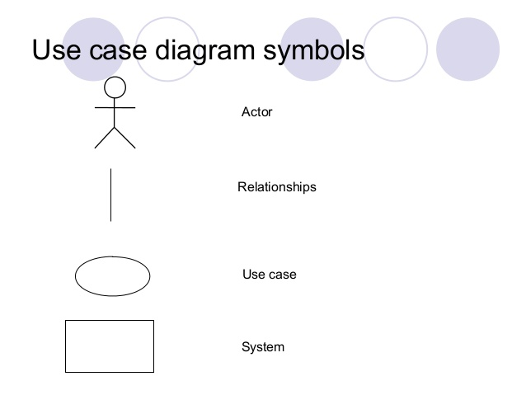

Figure : Use Case Symbols

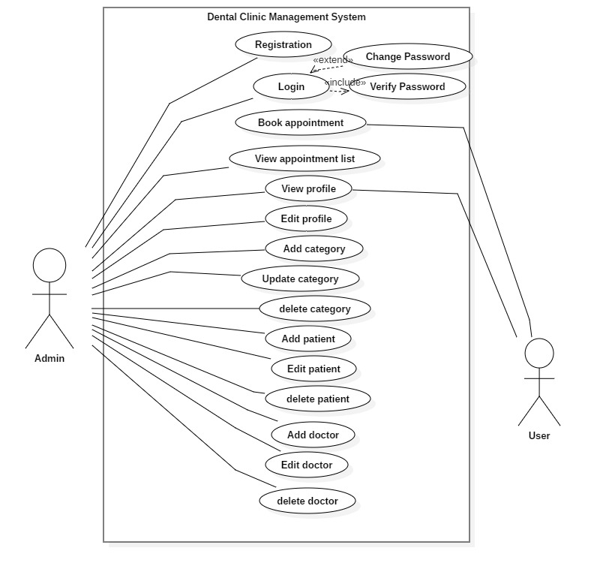

Figure : use case diagram

In this above diagram, there are two actors. i.e.  **Admin** and **User.** Admin can register and login. here, we can see admin can View appointment list, View profile, Edit profile, Add category, Update category, delete category, Add patient, Update patient, delete patient, Add doctor, Edit doctor, Delete doctor. At another point, user can book the appointment, view their own profile.

# Initial class diagram (NLA)

**Natural Language Analysis:**

To identify nouns, verbs and adjective from a scenario or illustrative text that is called natural language analysis. In this process noun is related to candidate classes, verbs is related to functionality or candidate operation and adjectives is related to attributes. After finding this, we have to find out a duplication, synonyms, and irrelevancies from a scenario to obtain final candidate classes.

|  |  |
| --- | --- |
| **Nouns** | **Verbs** |
| Nowadays, Businesses, Institutions, system, receptionist, space, time, paper, patient, information, clinic, Dental aide, name, age, gender, treatment, dentist, admin, user, patients list, Manually, Problem, Computerized, Responsible, Master list, Procedure. | Done, still using, still experiencing, consumes, find, store, need, ask, will undergo, identify, add, delete, update, login, register, book appointment, produce schedule, update patients detail, view, provide printed copy, create perspective |

* **Final Candidate classes (noun) are:**

Patient, Dentist, receptionist, Procedure.

* **Final candidate operations(verbs) are:**

Login, register, add, update and delete, book appointment, produce schedule, create perspectives.

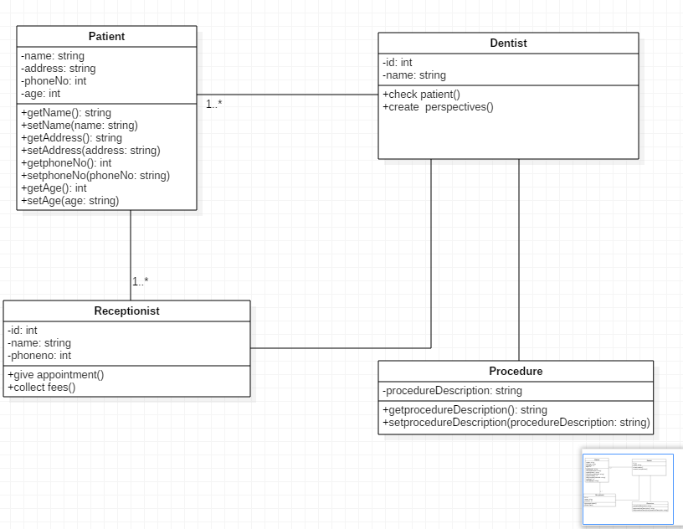

Figure 5: Class diagram of dental clinic

# Conclusion

Likewise, analysis of my project has been completed. Firstly, I have analyzed a requirement gathering and also activities that is involved in project. Then, feasibility study analysis should be identified to measure an ability of a project. After that, I have identified functional and non-functional requirements. Then, I have prioritized all according to Moscow techniques.

# References

Business Change Academy. (2017). *What Is CATWOE Analysis?* [Online] Available at: https://businesschange.co.za/what-is-catwoe-analysis/ [Accessed 1 May 2019].